Name - Hardik Chaudhari

Student ID - 240840325025

LINUX

Q1

#!/bin/bash

read -p "Enter the 4 Numbers " a b c d

if (( ( $a -gt $b ) && ( $a -gt $c ) && ( $a -gt $d) )); then

echo "$a is greater"

elif (( ( $b -gt $c ) && ( $b -gt $d ) && ( $b -gt $a) )); then

echo "$b is greater"

elif (( ( $c -gt $d ) && ( $c -gt $b ) && ( $c -gt $a) )); then

echo "$c is greater"

else

echo "$d is greater"

fi

product=$((a\*b\*c\*d))

echo "product of four numbers $product"

sum=$((a+b+c+d))

avg=$((sum/4))

echo "the average of the four number is $avg"

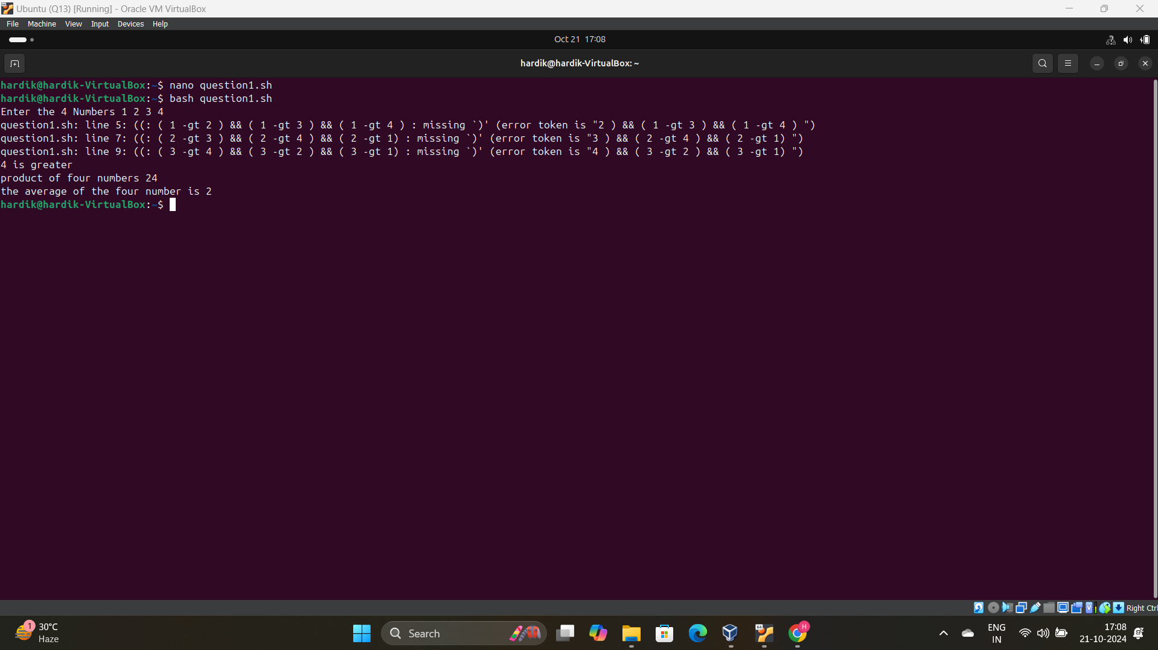

Q2

a)

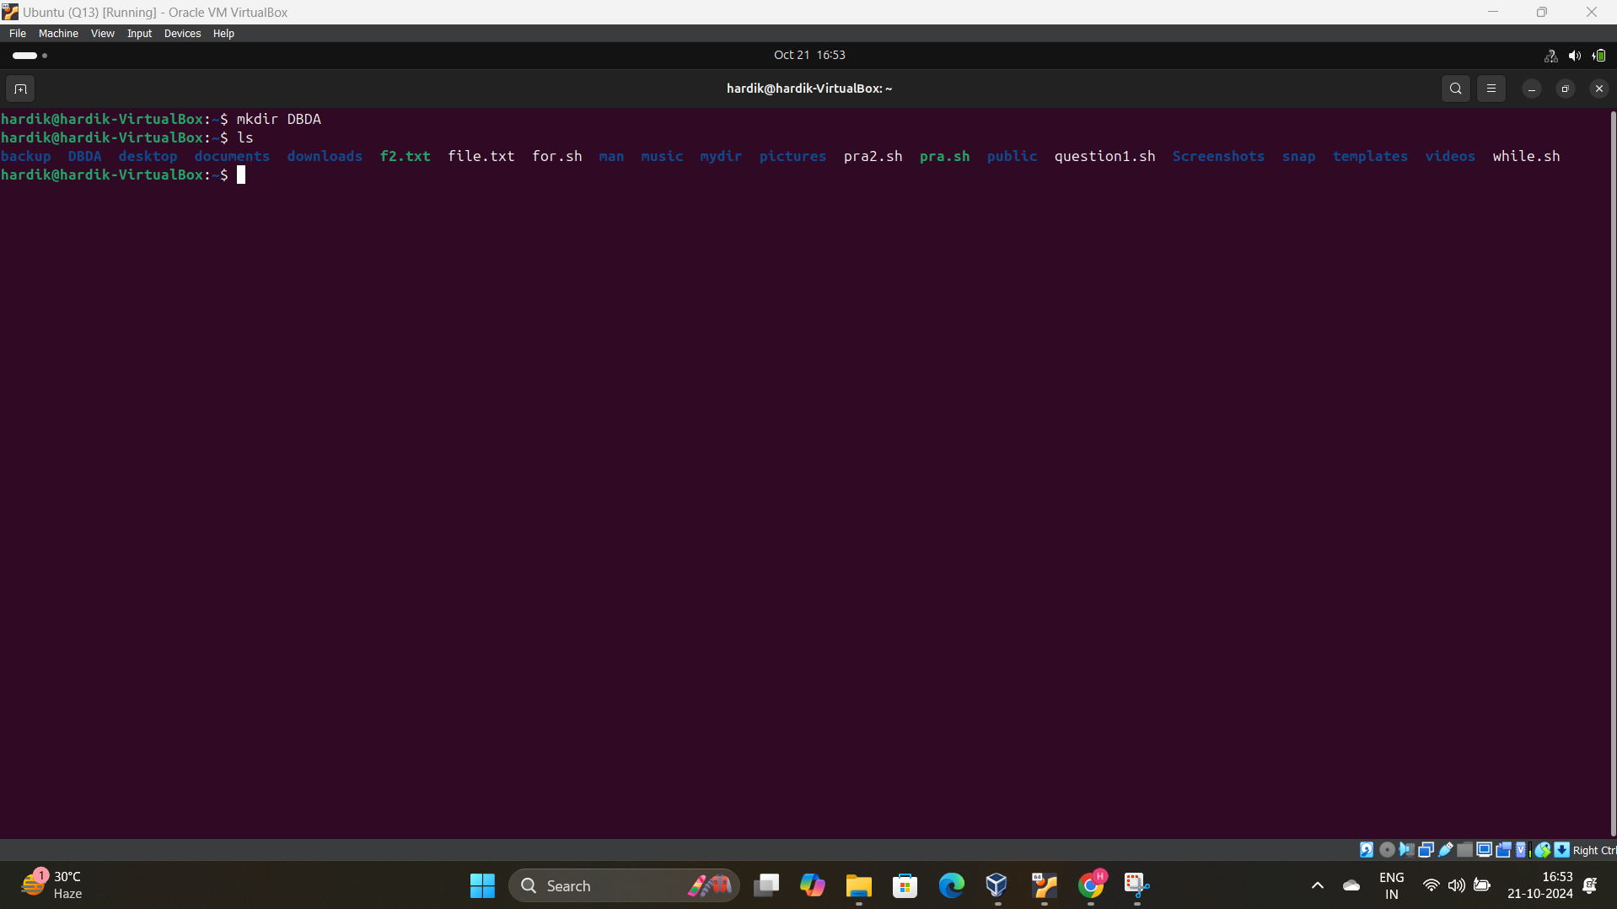

c)

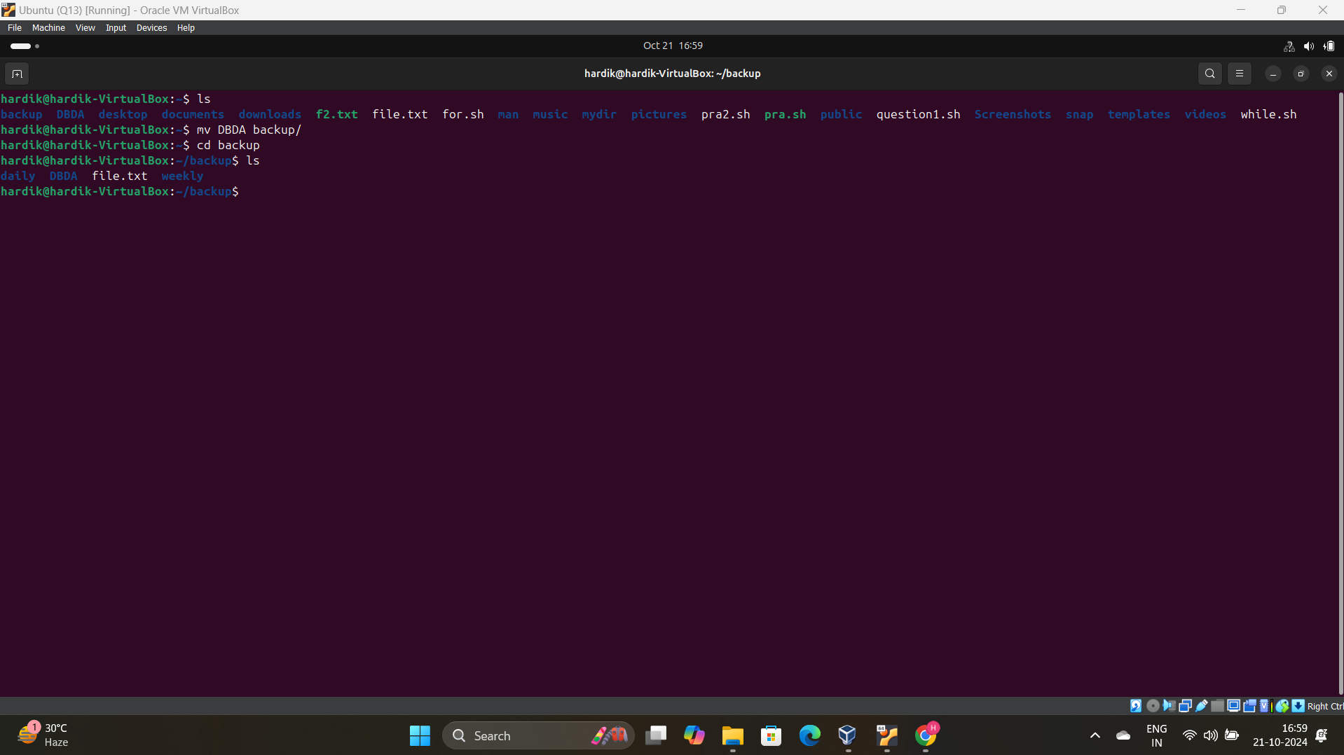

d)

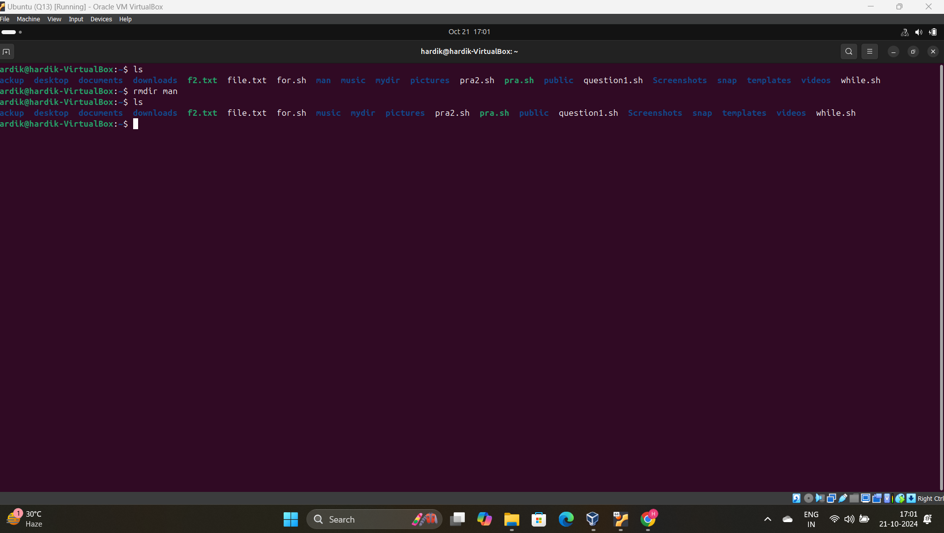

e)

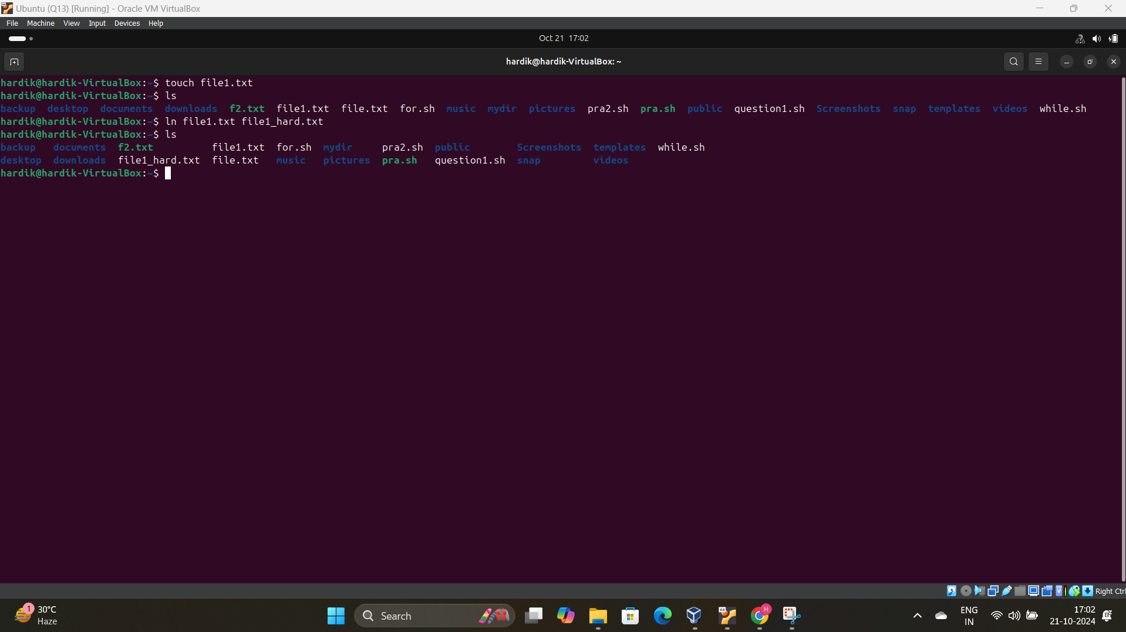

CLOUD

Create an IAM User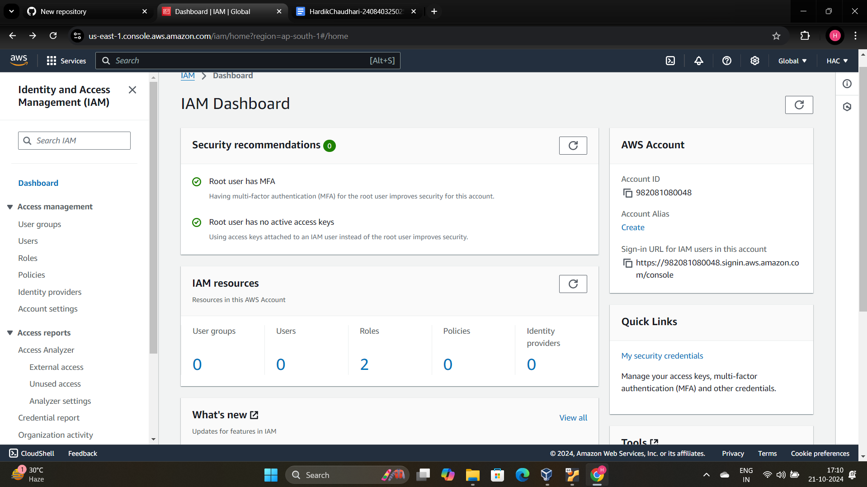

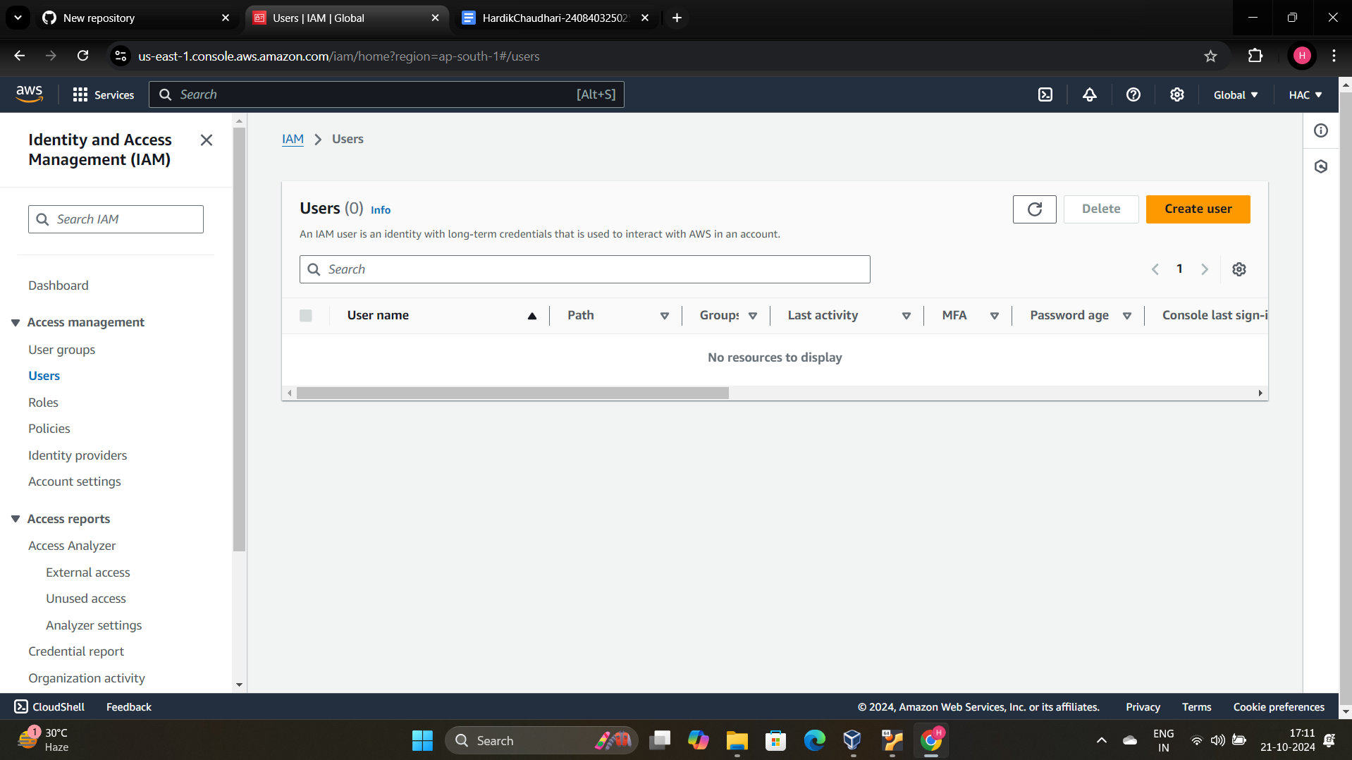

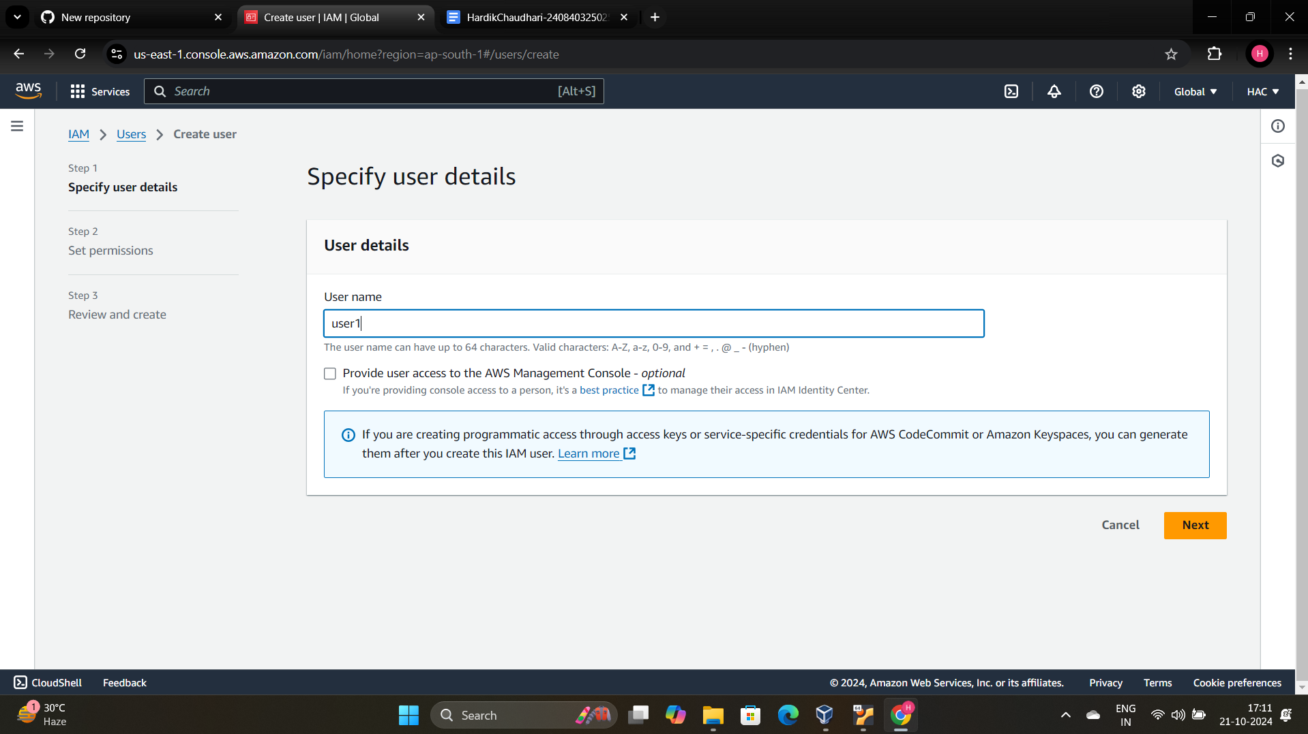

Give an EC3 2 Permission

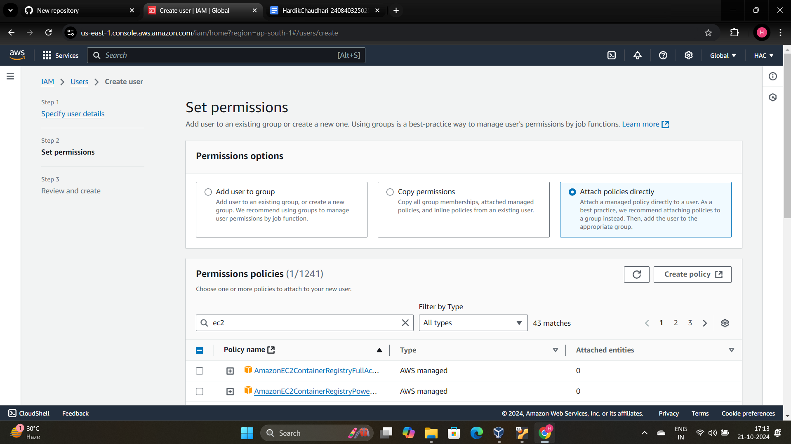

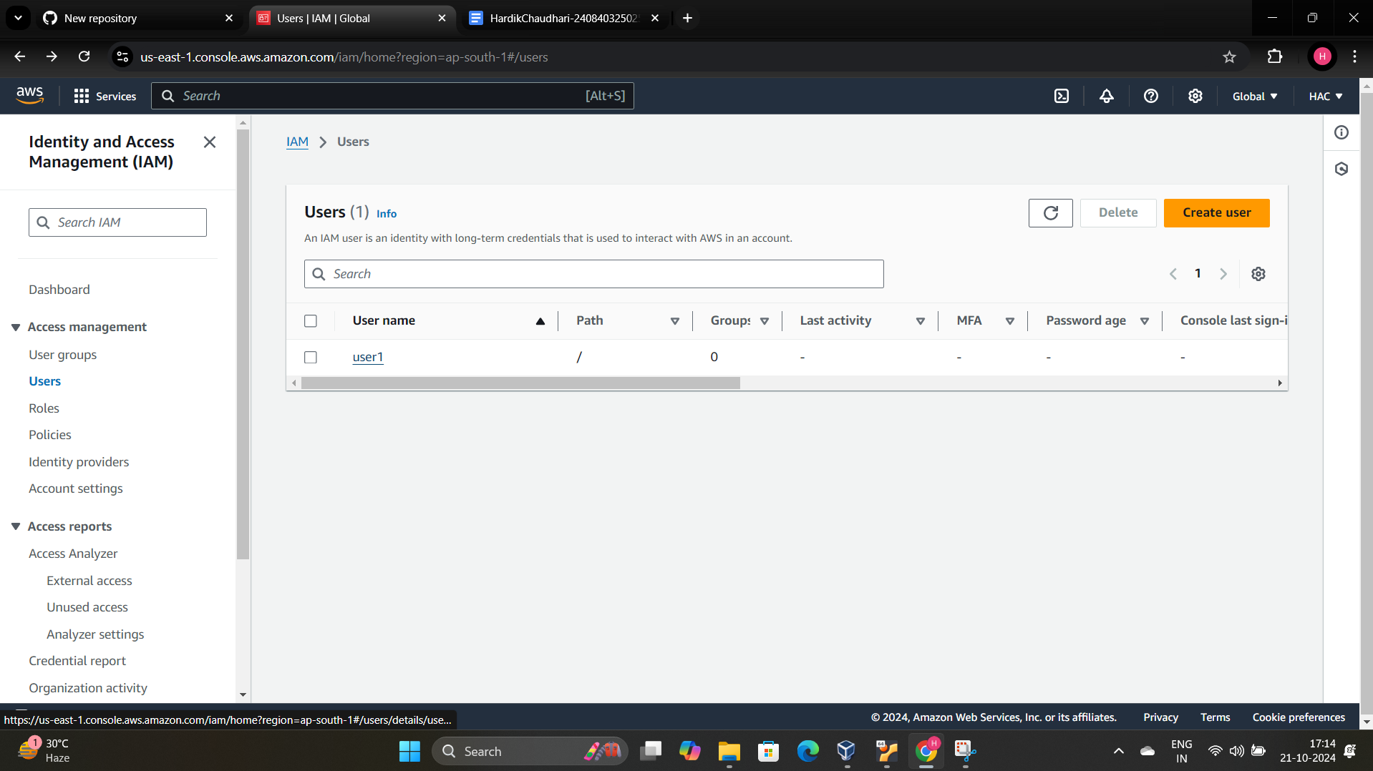



Giving an password and console authentification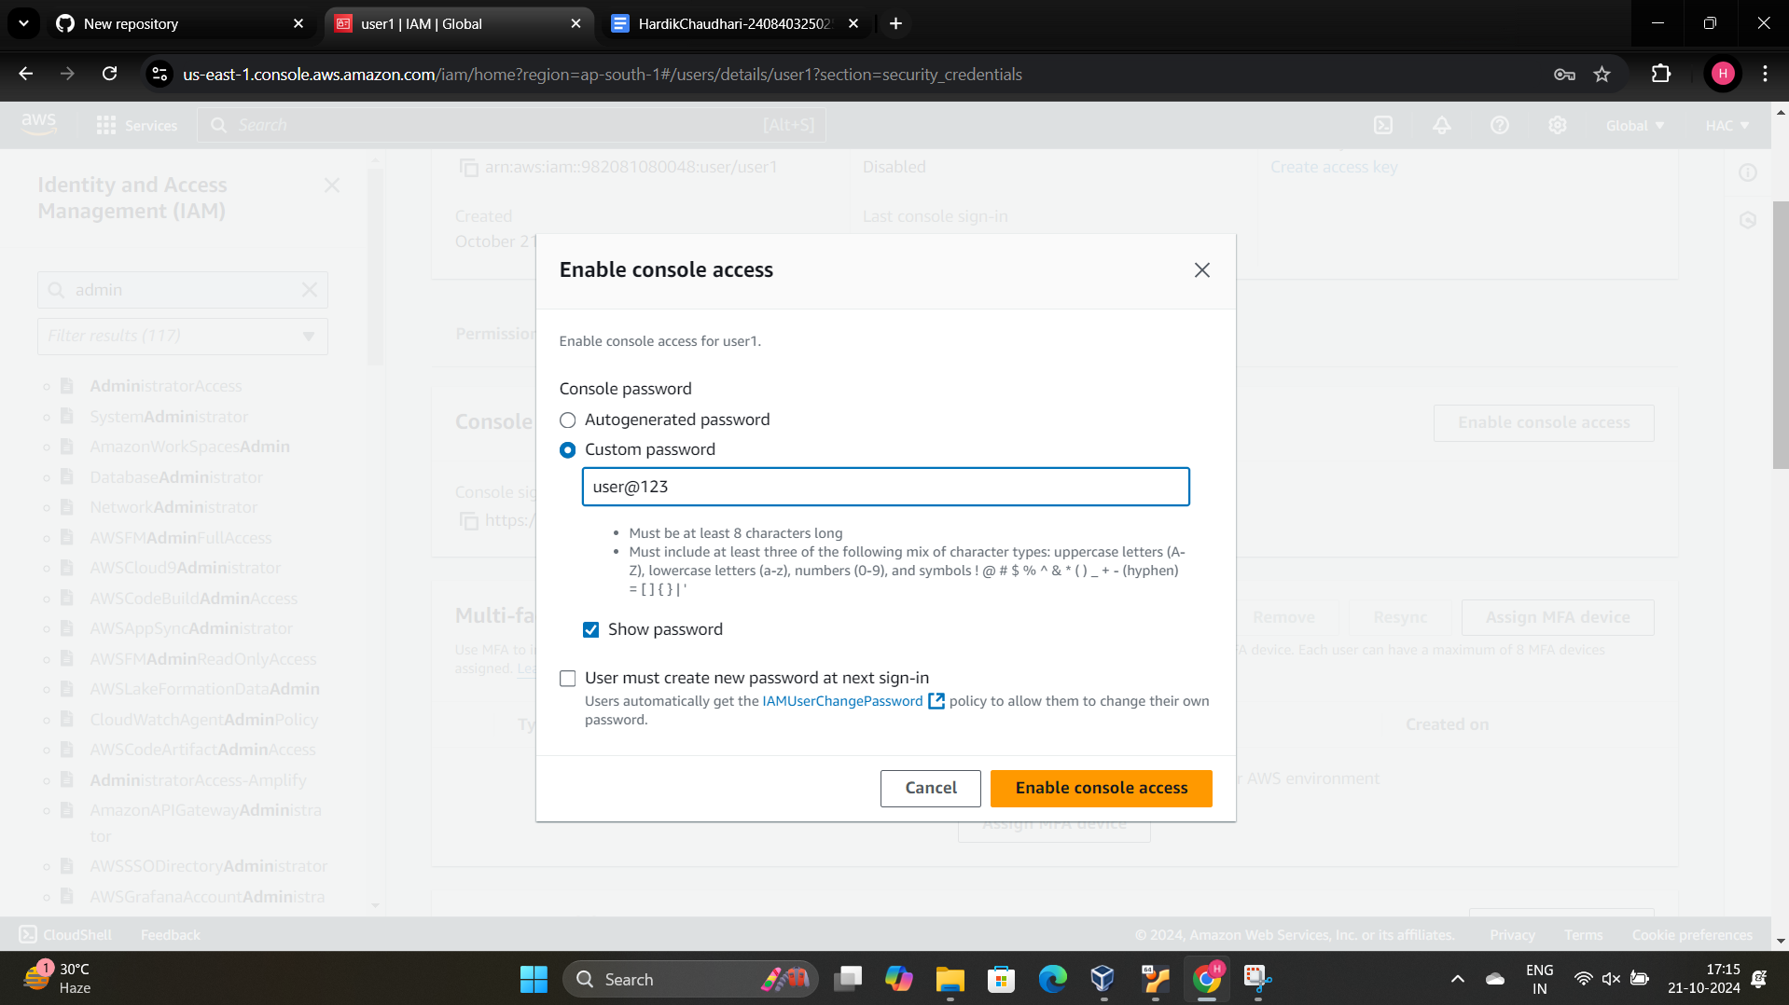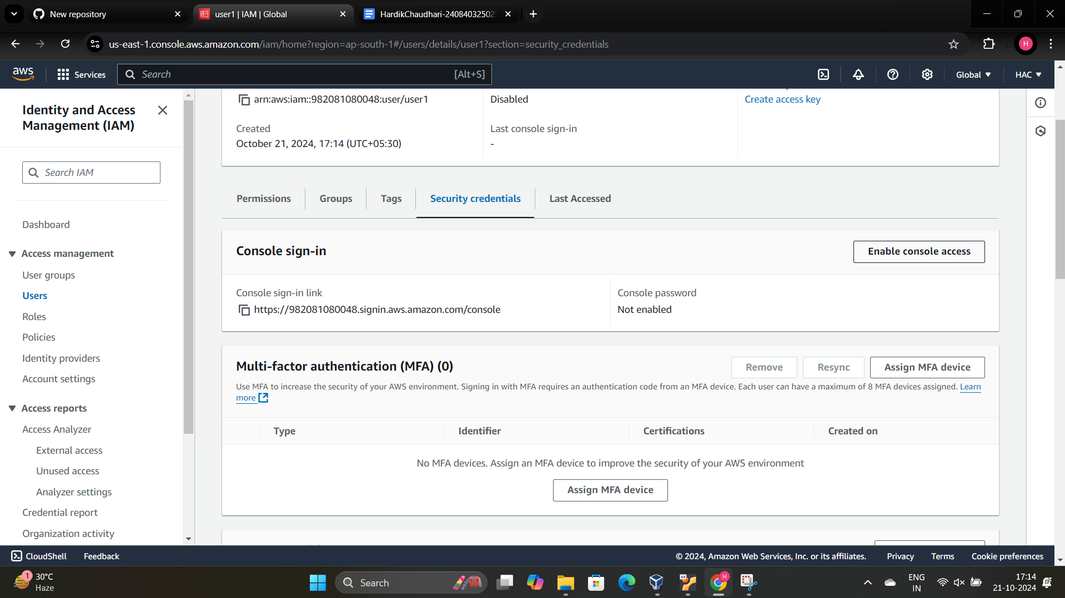

Log in the New User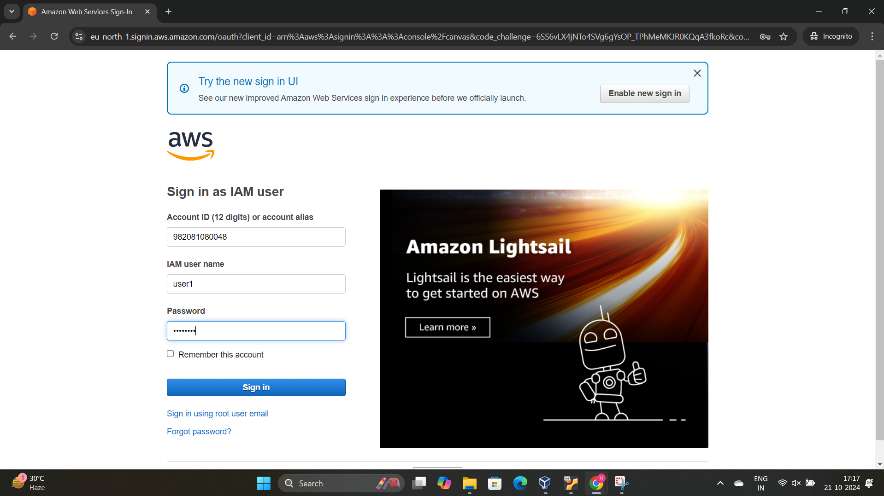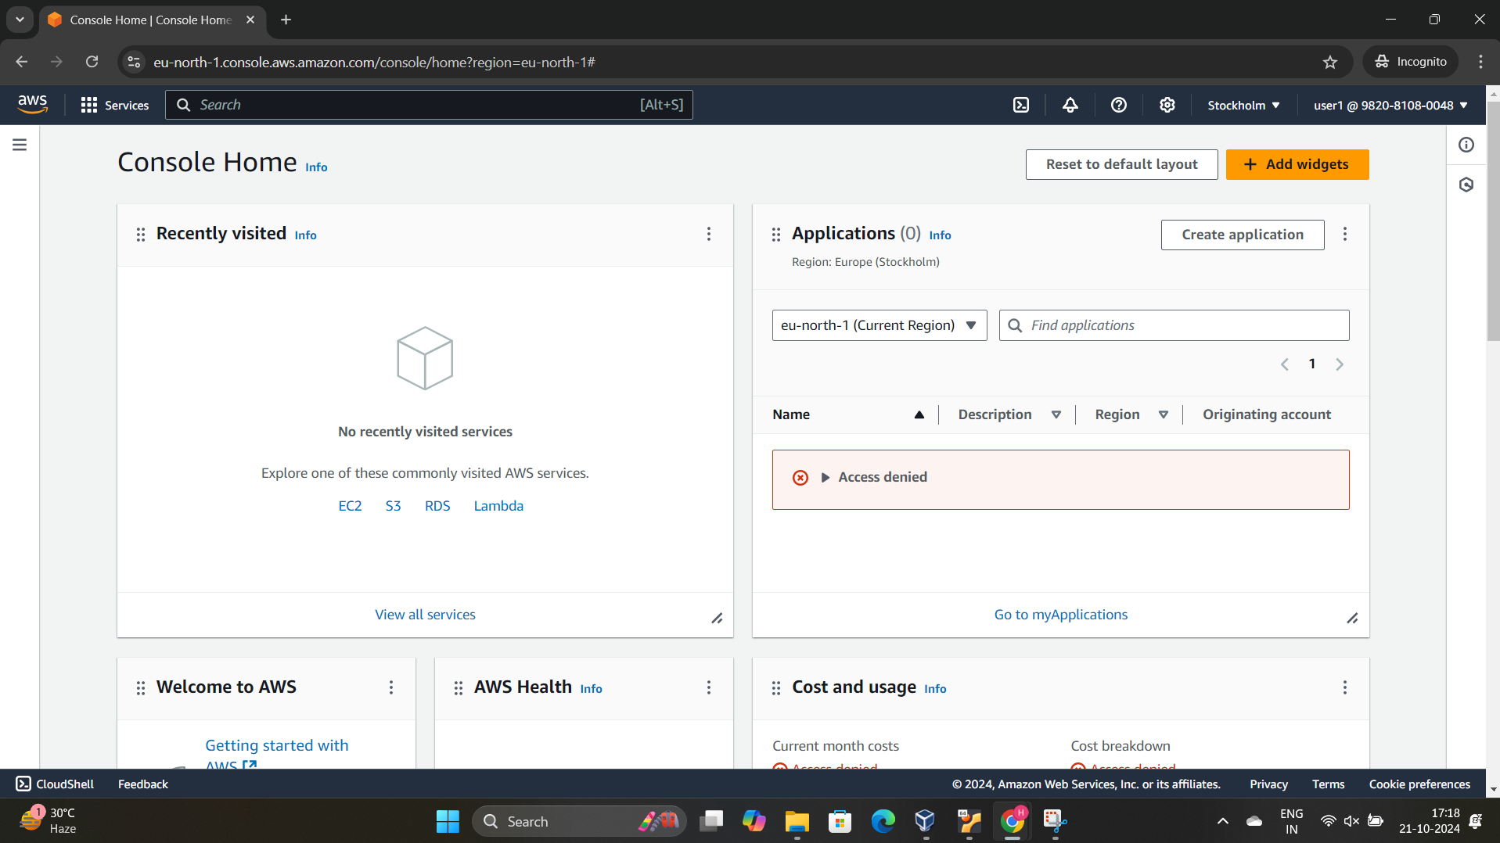

Create the EC2 Instance

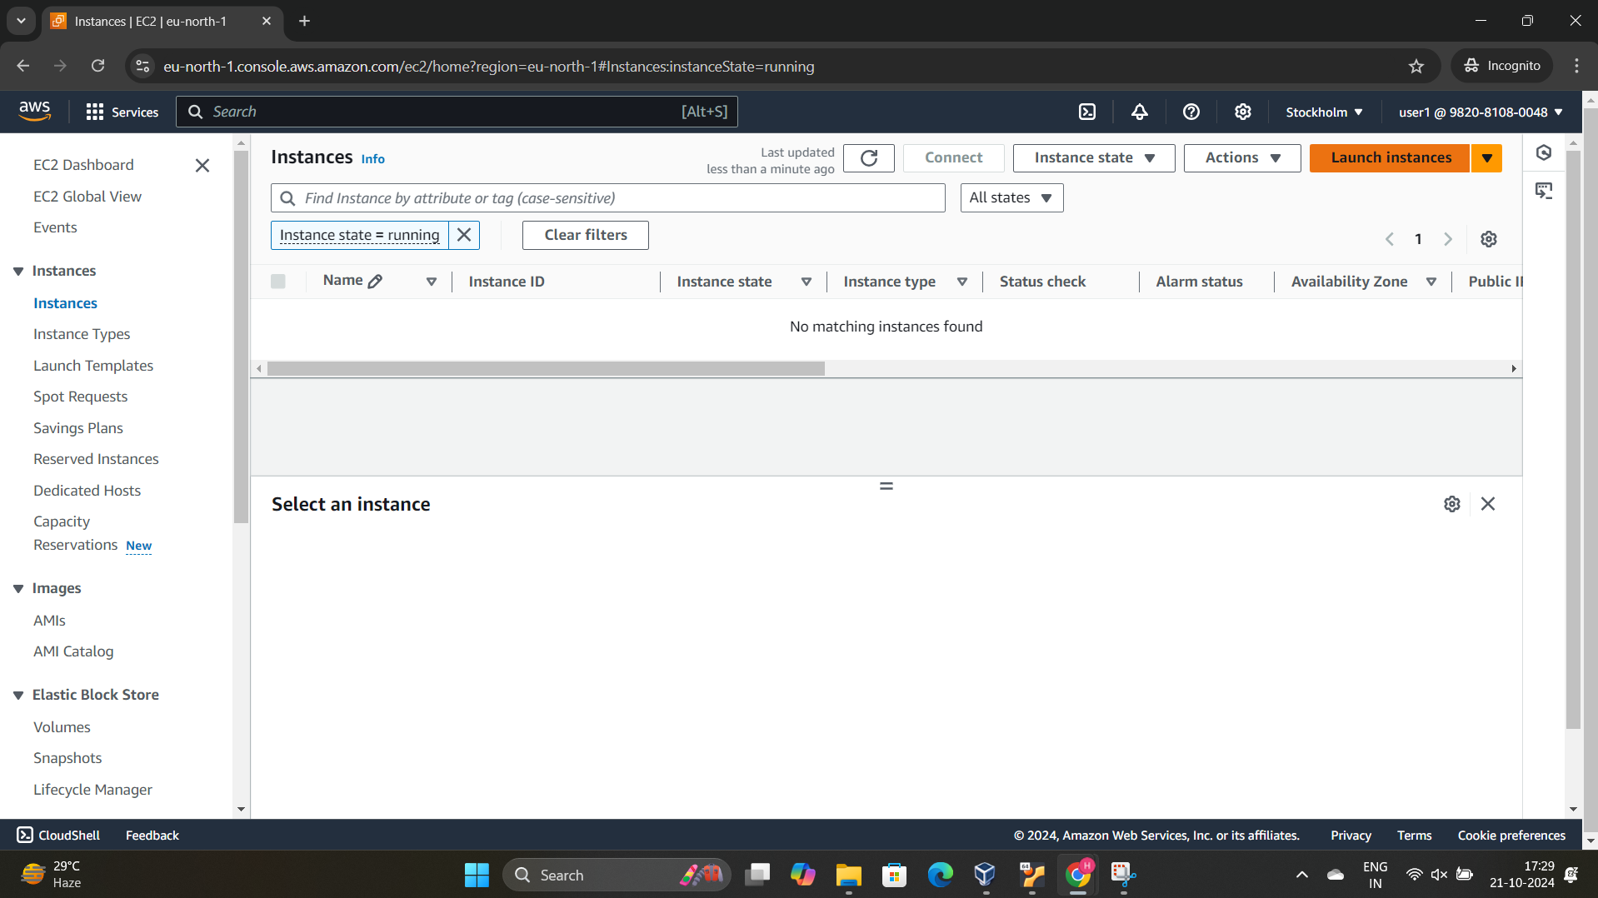

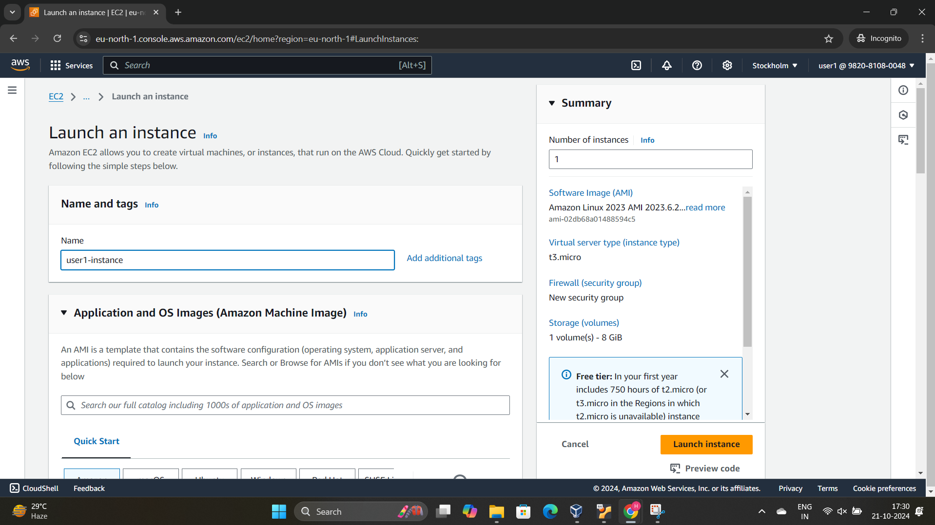

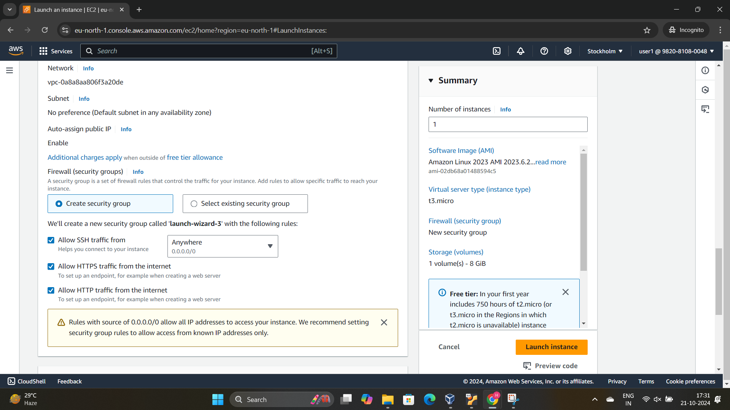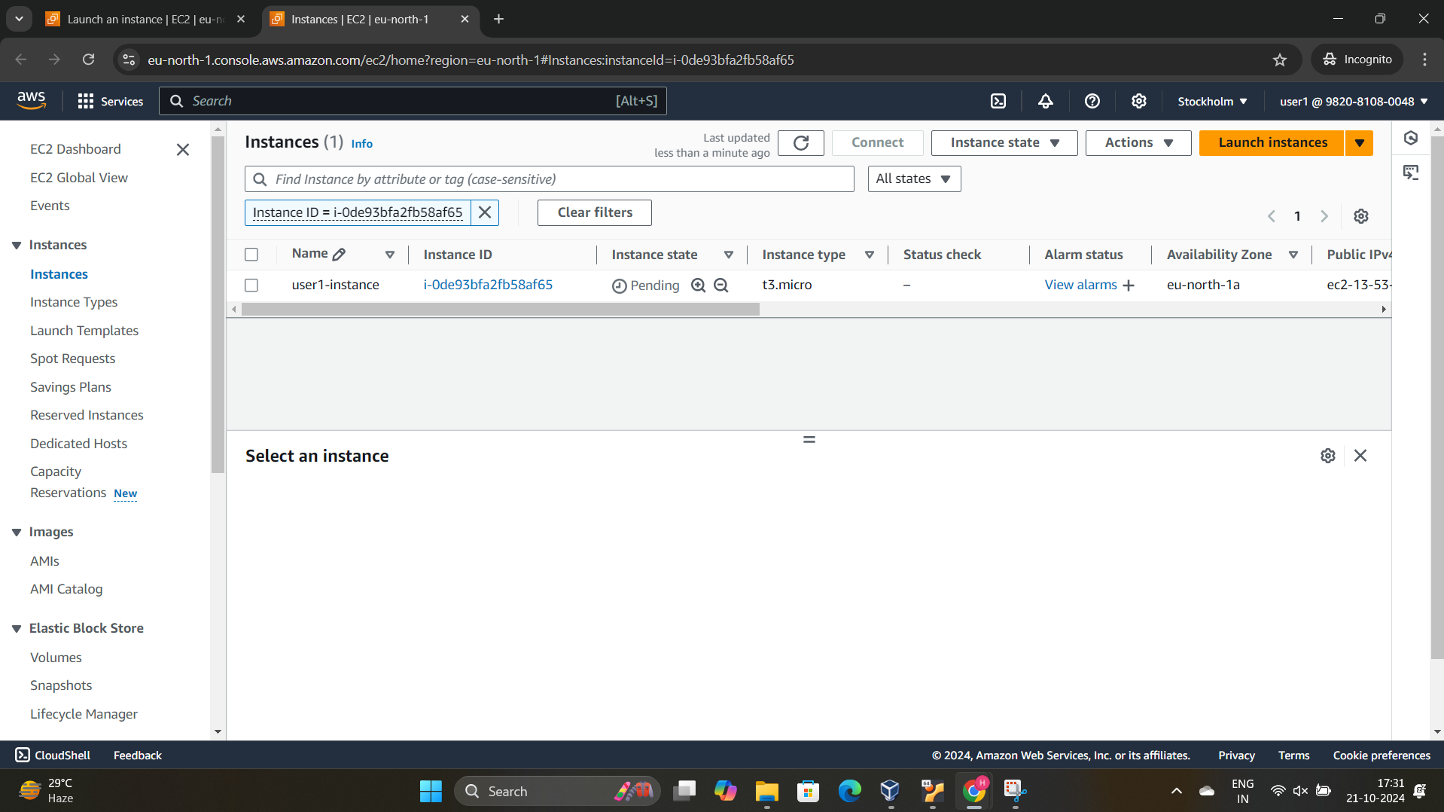

Create an connection VIA putty

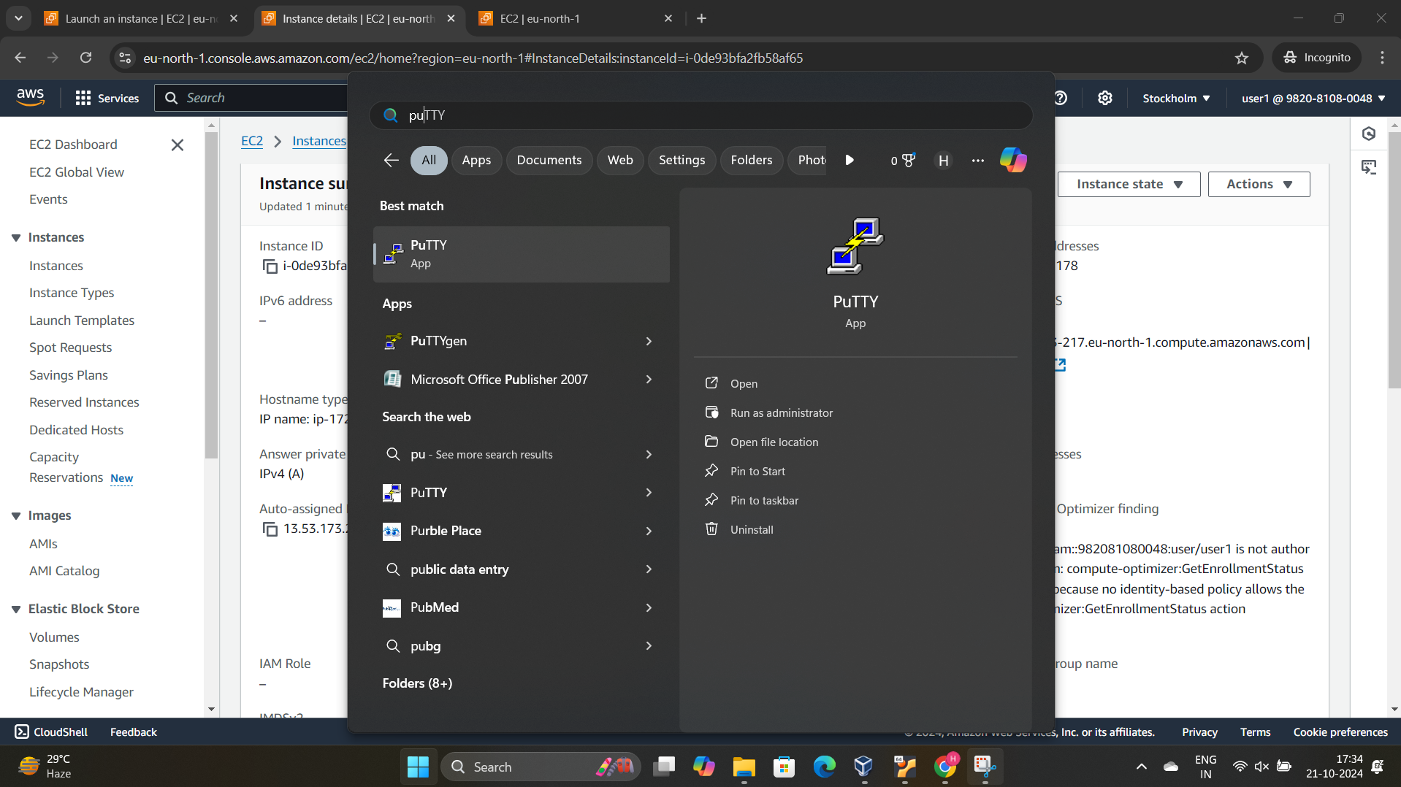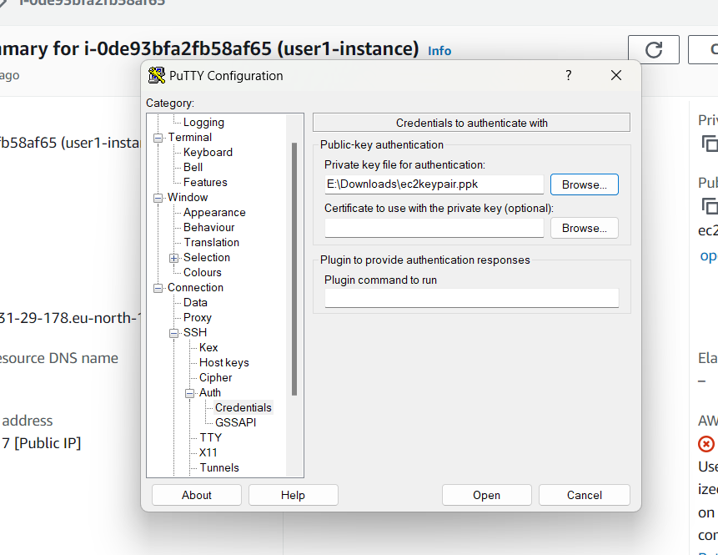



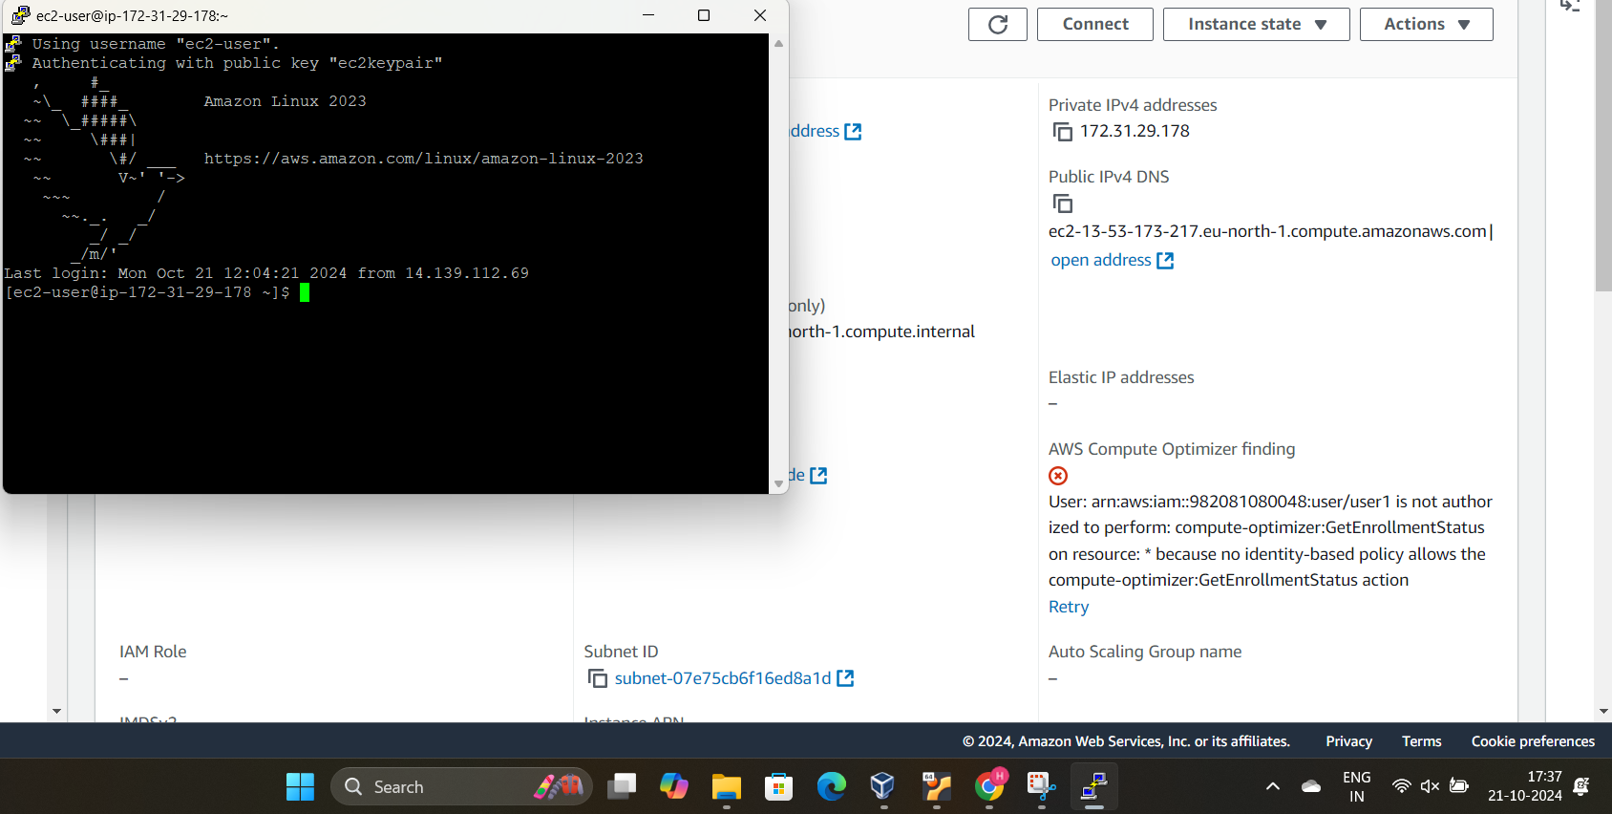

Create an S3 Bucket in the Root user

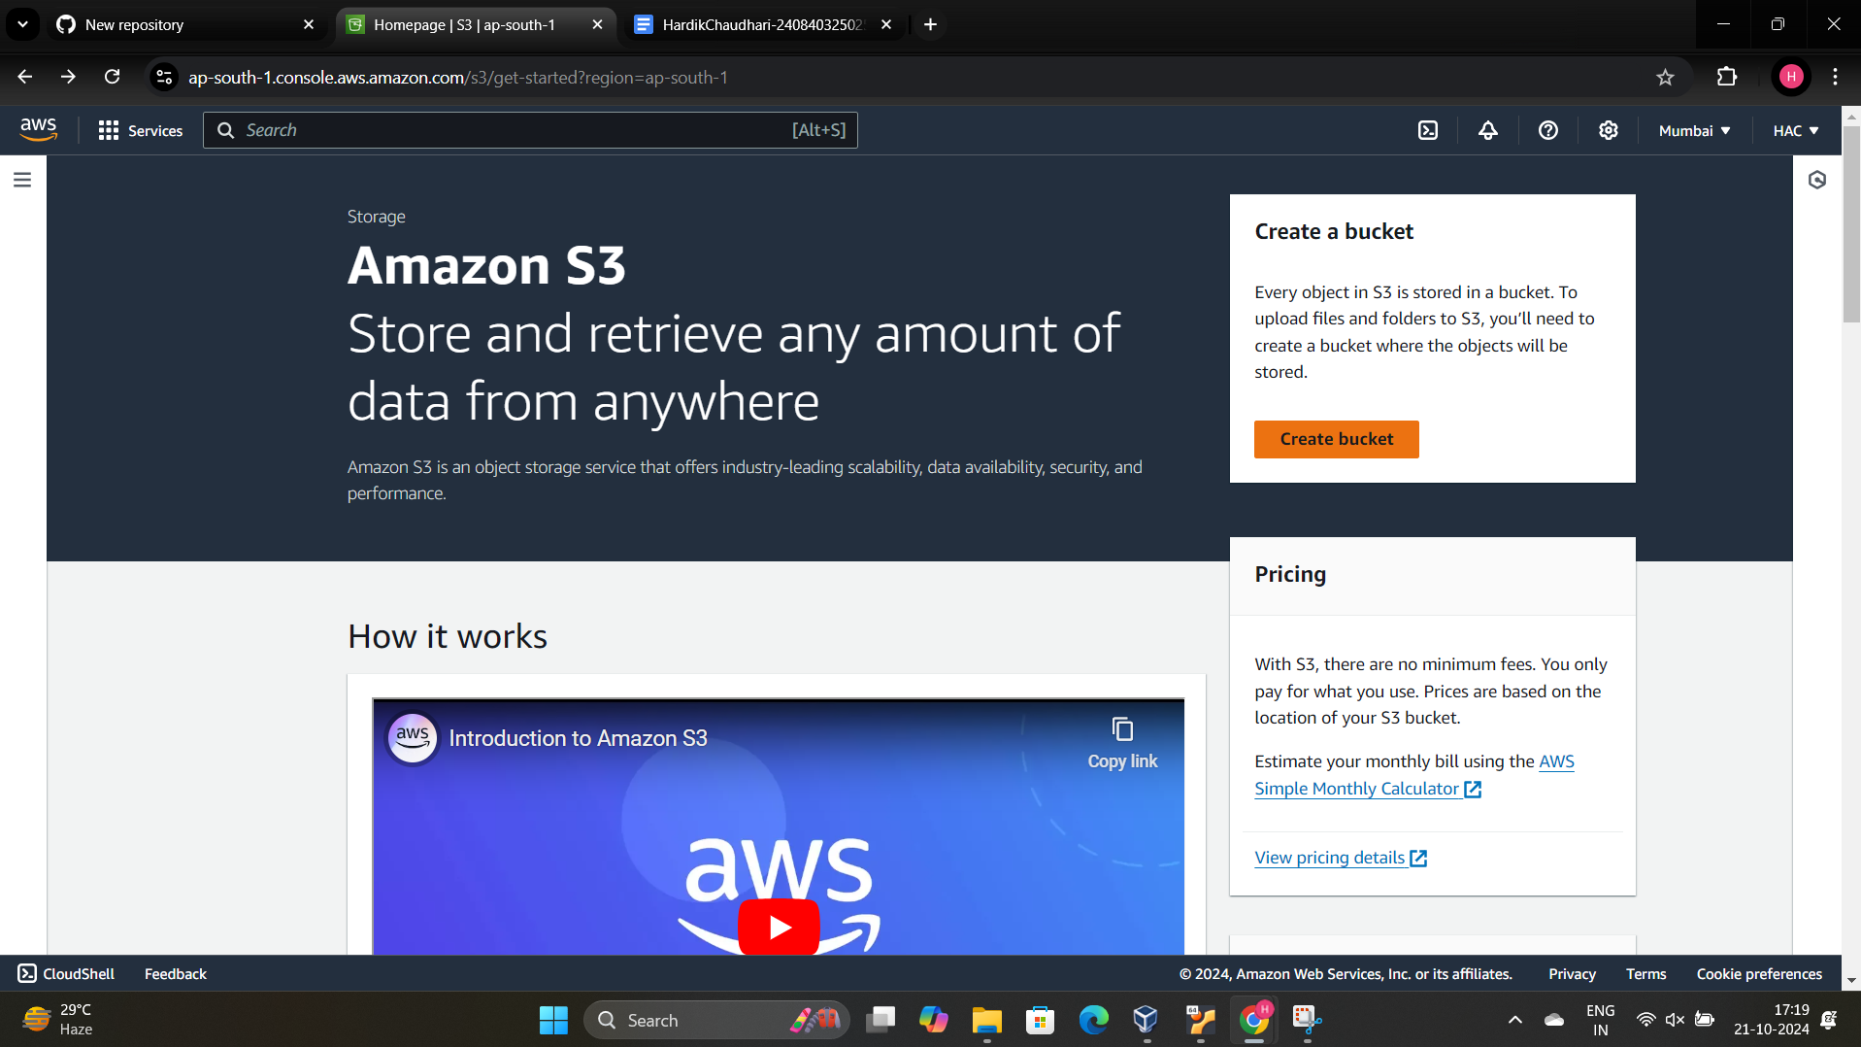

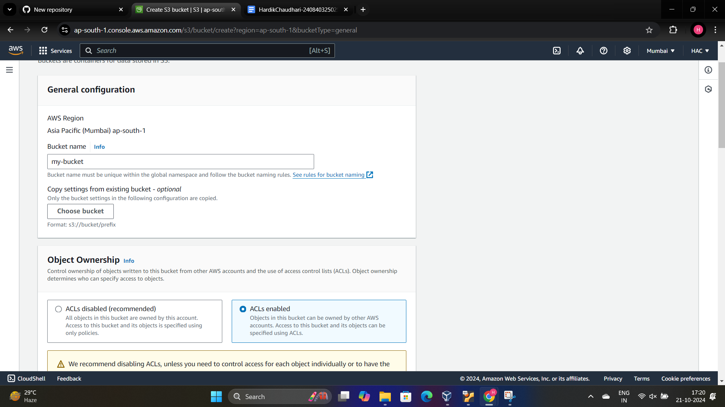

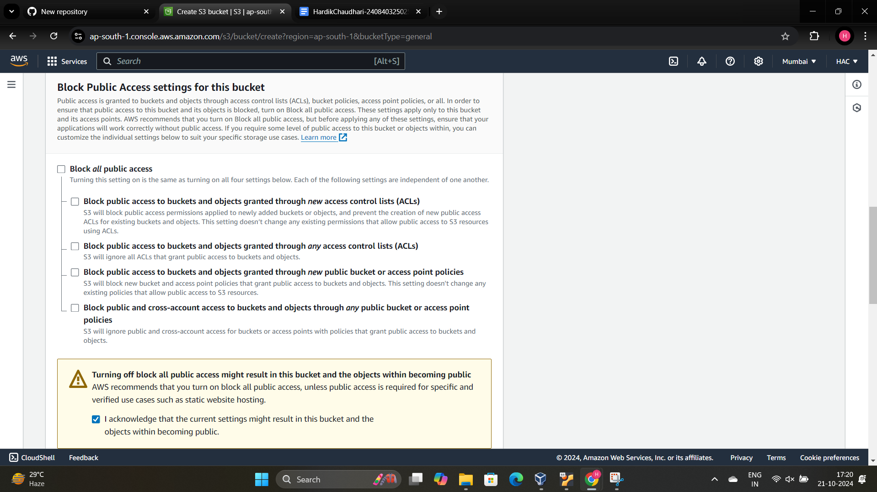

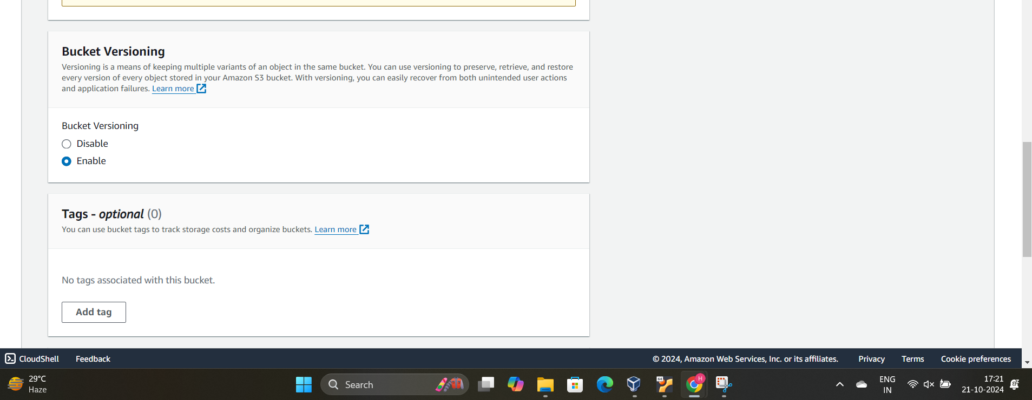

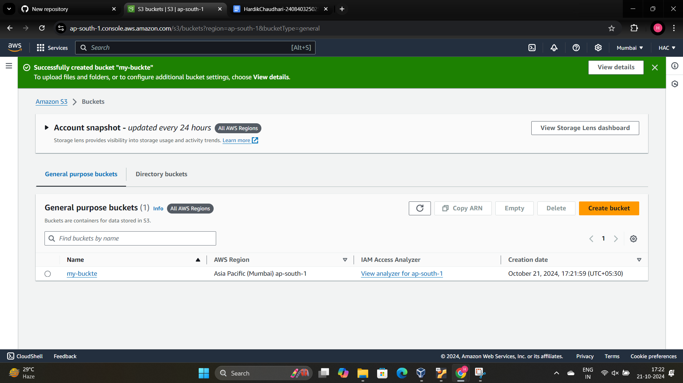

Enable the Static website Hosting

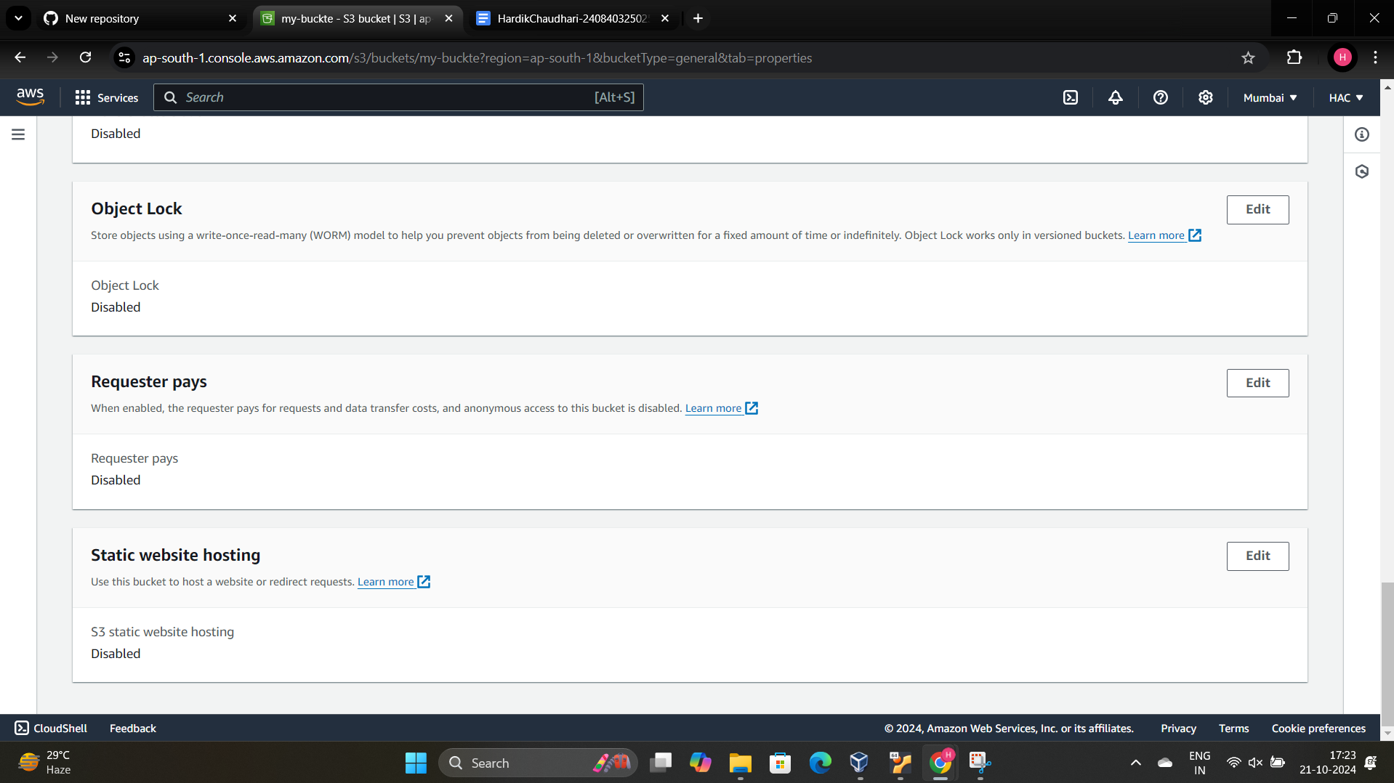

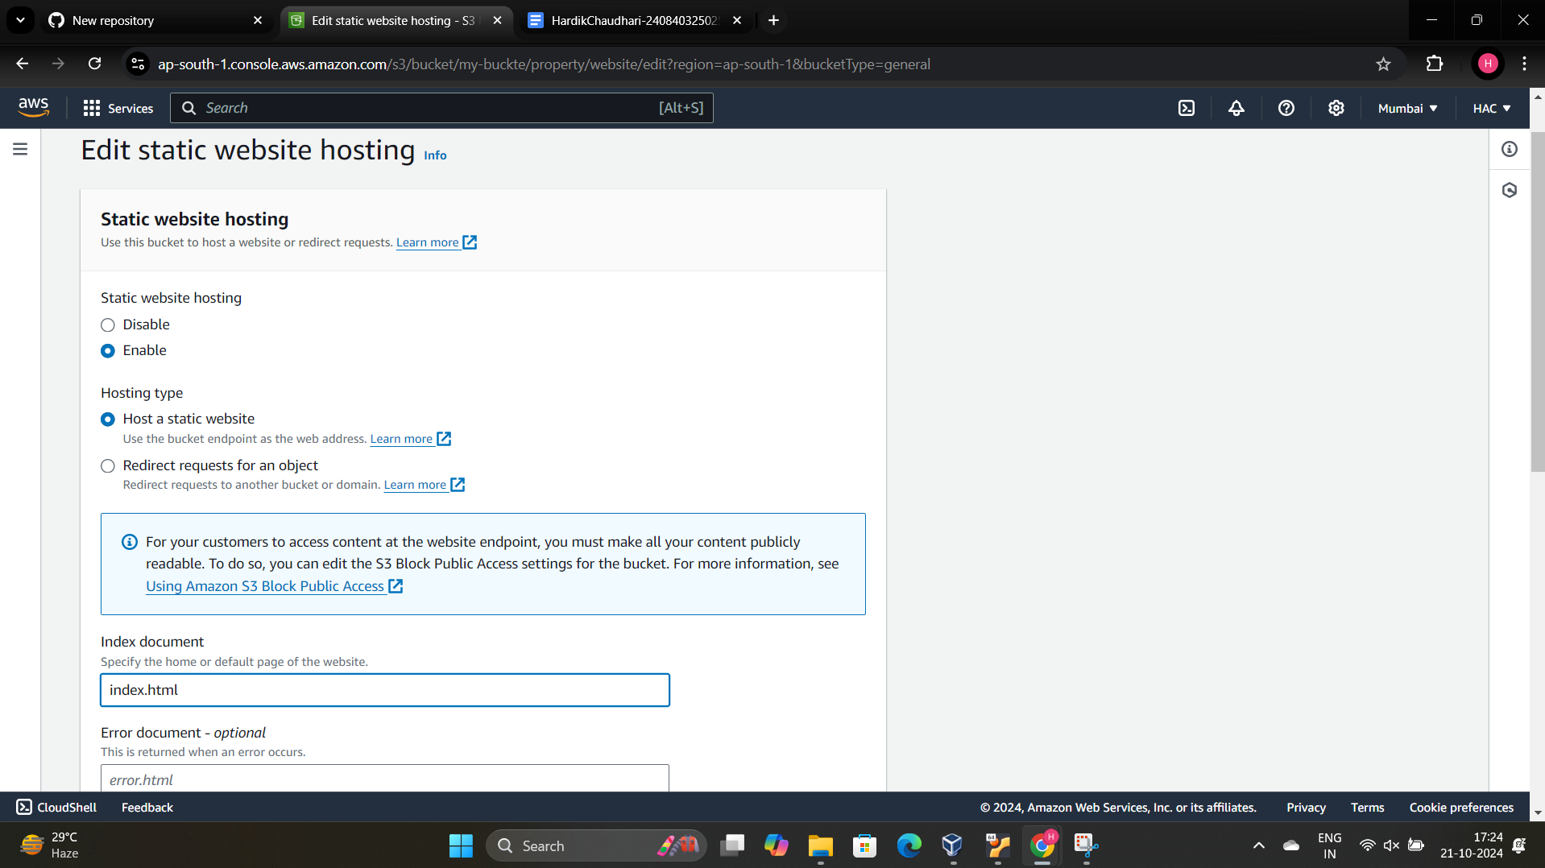

Upload the index file in the bucket

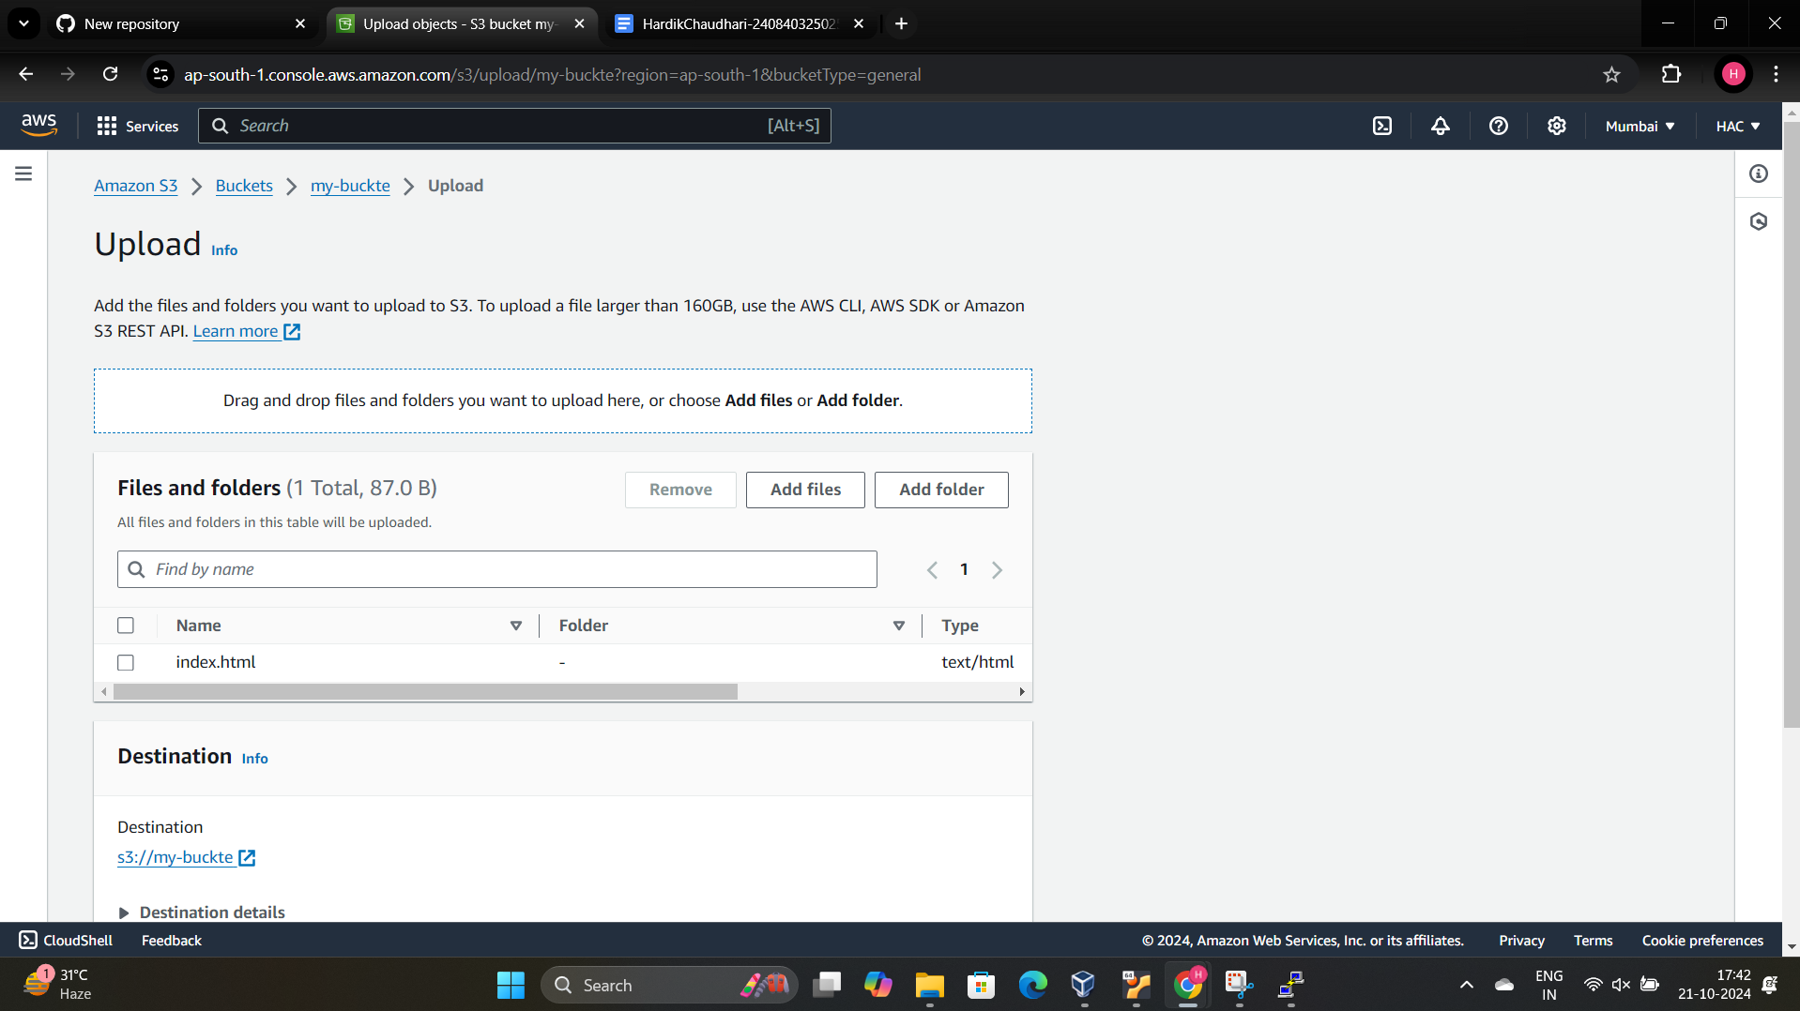

Make the File Public Using the ACL

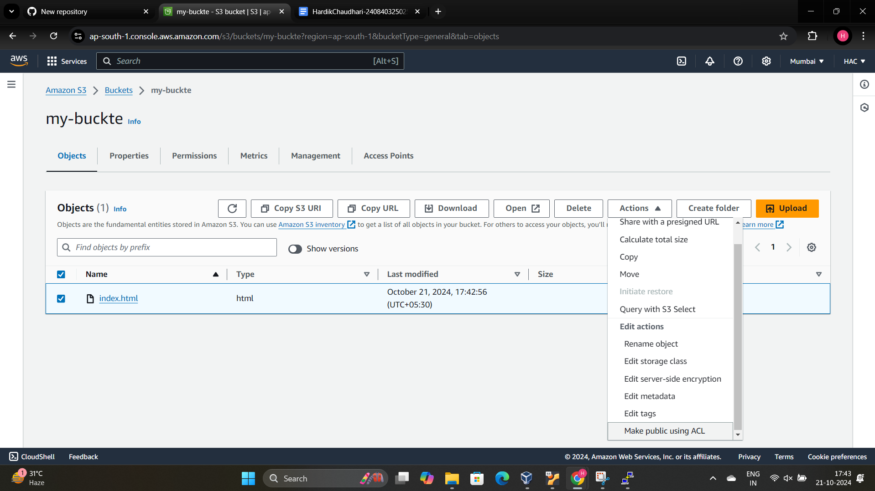

Copy the link

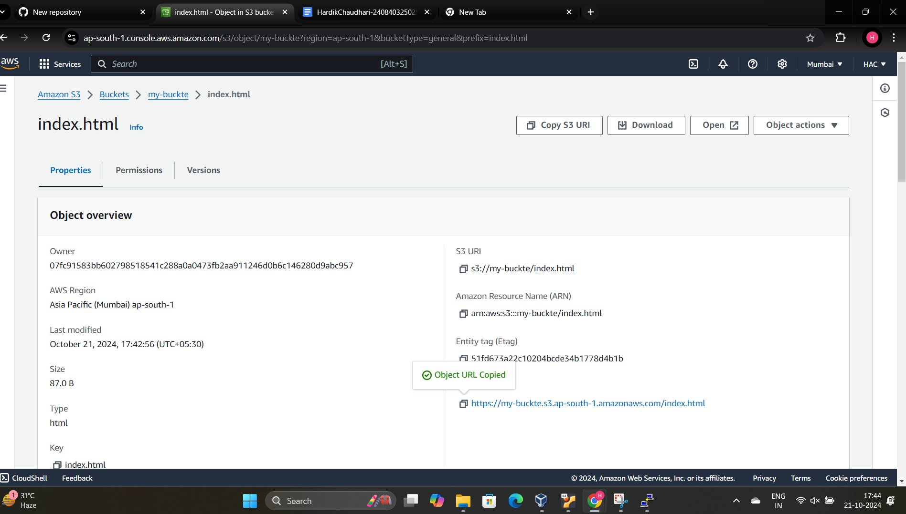

Paste the Link in the Browser and hit enter

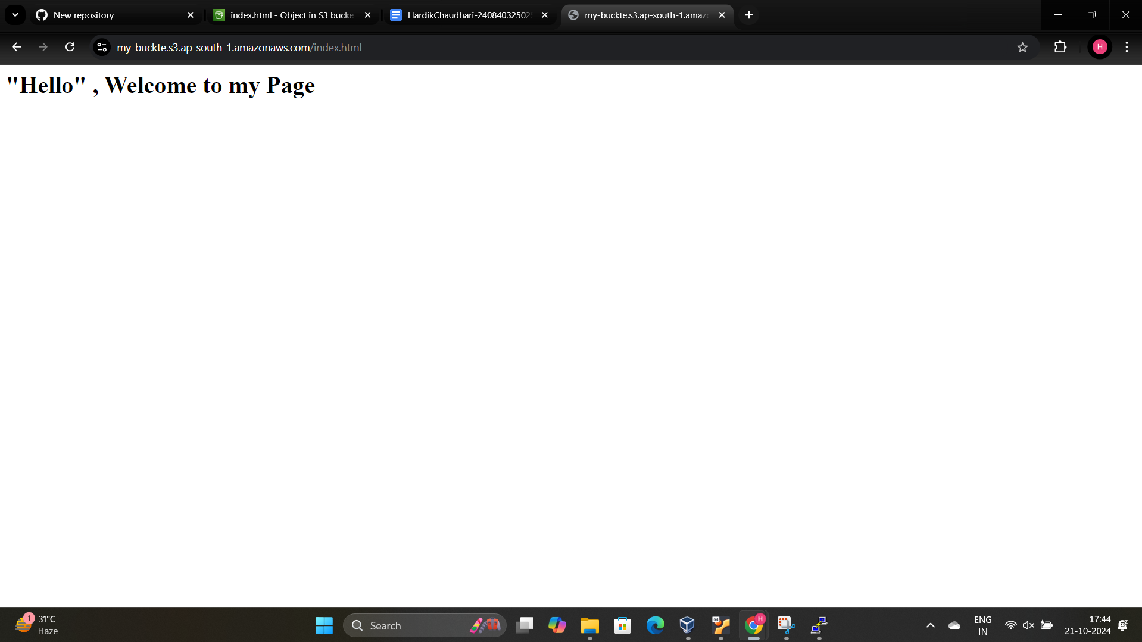

The public link :-<https://my-buckte.s3.ap-south-1.amazonaws.com/index.html>